Date: 23/06/2026
RE: External Facade Inspection - M & A apartments
Dear Body Corporate Committee,
Rope Access Technicians Pty Ltd has completed a visual inspection of the external facade at M & A apartments. Please find enclosed the inspection report and defect schedule.
Photos contained within this Word report have been compressed to control file size. Full-resolution images are retained separately and can be shared from the project Drive folder.
Should you have any questions, please feel free to contact our office.
Best Regards,
Rope Access Technicians Pty Ltd

INSPECTION OF EXTERNAL FACADE
M & A APARTMENTS
Prepared by Rope Access Technicians Pty Ltd

TABLE OF CONTENTS

DISCLAIMER
Whilst every care has been taken in the preparation of this document, any advice provided in it is general in nature. The client should seek expert advice from a structural engineer or other relevant professionals regarding specific works.
Rope Access Technicians Pty Ltd accepts no responsibility for any error or omission resulting from the use of this information.

DROP PLAN
The photos and repair references in this report relate to the drop labels recorded in the inspection app.
Drop plan 1: image unavailable

SUMMARY OF FINDINGS
DROP | Brick Work Cracking (Each) | Caulking Failing (LM) | Coatings Efflorescence (Each) | Coatings Missing Paint (m2) | Coatings Paint Failure (m2) | Coatings Paint mess (Count) | Concrete Cracking (LM) | Concrete Rust Spot (Each) | Concrete Spalling (L) | Waterproofing Pin Holing (m2)
A | - | - | - | - | - | - | 1 | - | - | -
B | - | - | - | 0.5 | - | - | 52 | - | - | -
D | - | - | - | 0.5 | - | - | - | - | - | -
E | - | - | - | 0.5 | - | - | 9 | 1 | - | -
F | - | - | - | - | 0.5 | 1 | 9 | - | - | -
G | - | - | 2 | 5 | - | - | 60 | - | - | -
I | - | 1 | 3 | - | - | - | 51 | - | - | -
J | 15,000 | 1 | - | 9 | 1,000,000 | - | - | - | - | 1
K | - | - | - | - | - | - | 3 | - | 5 | -
TOTAL | 15,000 | 2 | 5 | 15.5 | 1,000,000.5 | 1 | 185 | 1 | 5 | 1

SUMMARY OF FINDINGS CONTINUED
DROP | Windows & Doors Frame Defect (Each)
A | -
B | -
D | -
E | -
F | -
G | -
I | -
J | 1
K | -
TOTAL | 1

REPORT ASSUMPTIONS & ROUNDINGS
Concrete spalling litres are calculated from length x height x depth in millimetres, converted to litres.
For the purposes of this report, we have assumed that the spalling has a repair depth of 60mm.
The spreadsheet includes actual litres, nearest 1L, and nearest 5L rounded-up quantities.
Area defects include actual square metres and rounded-up nearest 0.5m2 quantities.
Lineal defects include rounded-up nearest 1m quantities.
The report includes one compressed photo per defect to control report size.
Full-resolution originals remain in the project photo folder. They can be accessed here:
Not available
The Spreadsheet with additional data can be view here:
Not available
These links provide read only files but you can download/copy them and edit them once they are off our server.

DEFECTS FOUND
Defect Type | Sub-Type | Count | Pricing Quantity
Brick Work | Cracking | 1 | 15,000 ea
Caulking | Failing | 2 | 2 LM
Coatings | Efflorescence | 2 | 5 ea
Coatings | Missing Paint | 6 | 15.5 m2
Coatings | Paint Failure | 2 | 1,000,000.5 m2
Coatings | Paint mess | 1 | -
Concrete | Cracking | 13 | 185 LM
Concrete | Rust Spot | 1 | 1 ea
Concrete | Spalling | 1 | 5 L
Waterproofing | Pin Holing | 1 | 1 m2
Windows & Doors | Frame Defect | 1 | 1 ea
TOTAL |  | 31

DEFECT SCHEDULE & PHOTOS

Drop A - Defect Schedule
Repair # | Level | Location | Defect Type | Length mm | Height mm | Depth mm | Qty | Round Up | Comments
A.21.1 | 21 | Wall | Concrete - Cracking | 500 |  |  |  | 1 LM | -

Drop A - Photo Schedule
A.21.1 - Concrete - Cracking
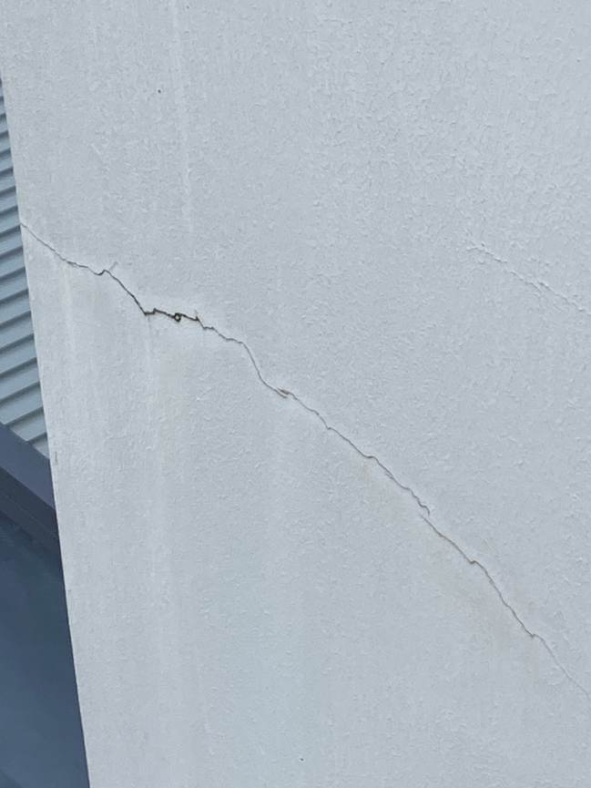

Drop B - Defect Schedule
Repair # | Level | Location | Defect Type | Length mm | Height mm | Depth mm | Qty | Round Up | Comments
B.3.1 | 3 | Parapet Wall | Concrete - Cracking | 2000 |  |  |  | 2 LM | -
B.1.1 | 1 | Wall | Concrete - Cracking | 50000 |  |  |  | 50 LM | -
B.1.2 | 1 | Wall | Coatings - Missing Paint | 100 | 10 |  |  | 0.5 m2 | -

Drop B - Photo Schedule
B.3.1 - Concrete - Cracking  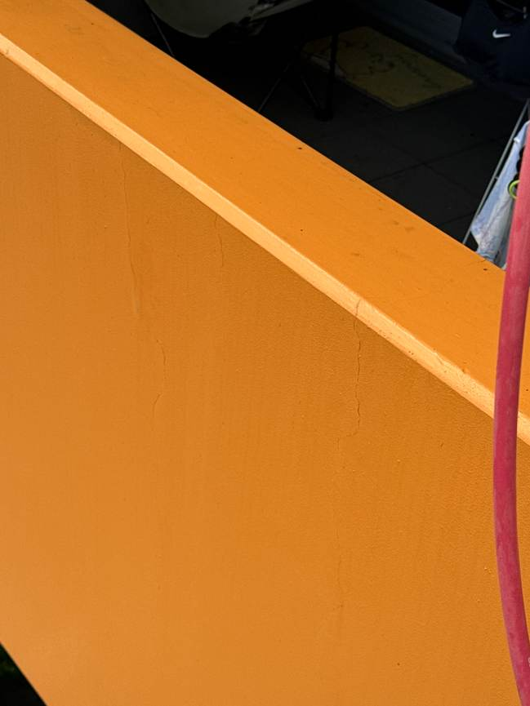 | B.1.1 - Concrete - Cracking  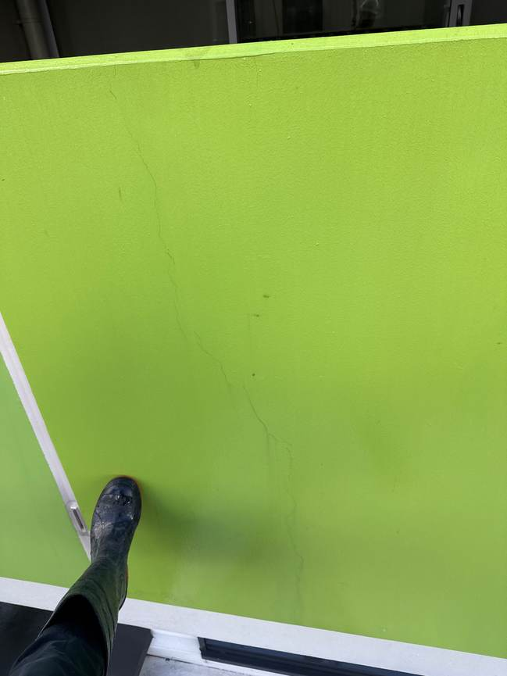 | B.1.2 - Coatings - Missing Paint  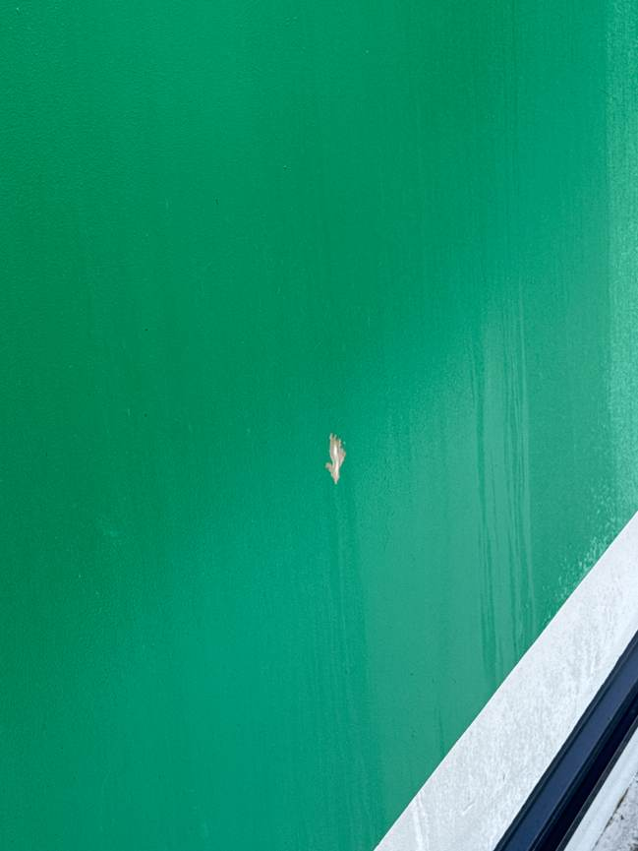

Drop D - Defect Schedule
Repair # | Level | Location | Defect Type | Length mm | Height mm | Depth mm | Qty | Round Up | Comments
D.18.1 | 18 | Slab Top | Coatings - Missing Paint | 400 | 250 |  |  | 0.5 m2 | -

Drop D - Photo Schedule
D.18.1 - Coatings - Missing Paint
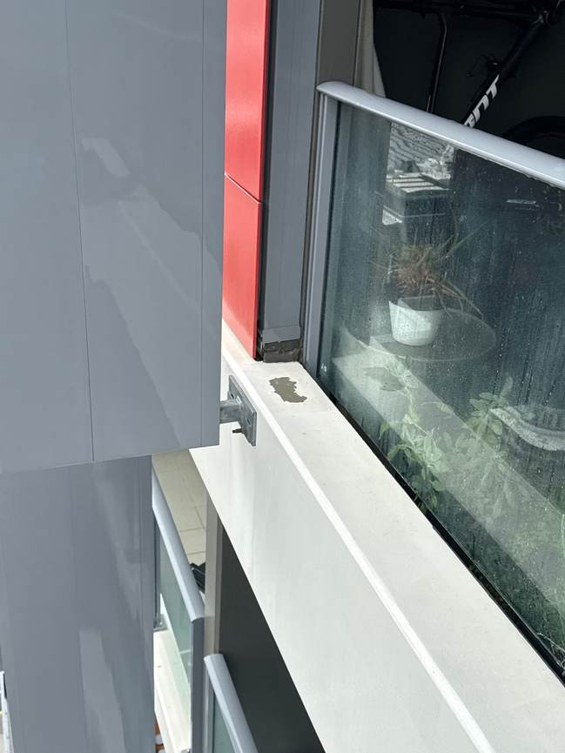

Drop E - Defect Schedule
Repair # | Level | Location | Defect Type | Length mm | Height mm | Depth mm | Qty | Round Up | Comments
E.R.1 | 22 | Slab End | Concrete - Cracking | 1000 |  |  |  | 1 LM | -
E.20.1 | 20 | Slab End | Concrete - Cracking | 7000 |  |  |  | 7 LM | -
E.9.1 | 9 | Slab End | Concrete - Rust Spot |  |  |  | 1 | 1 ea | -
E.6.1 | 6 | Wall | Concrete - Cracking | 1000 |  |  |  | 1 LM | -
E.5.1 | 5 | Slab End | Coatings - Missing Paint | 10000 | 1 |  |  | 0.5 m2 | -

Drop E - Photo Schedule
E.R.1 - Concrete - Cracking  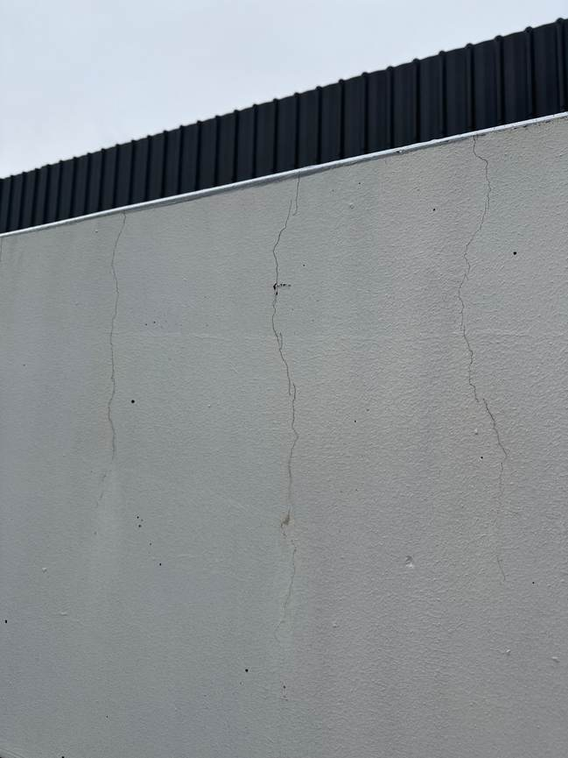  +1 additional photo available in Drive | E.20.1 - Concrete - Cracking  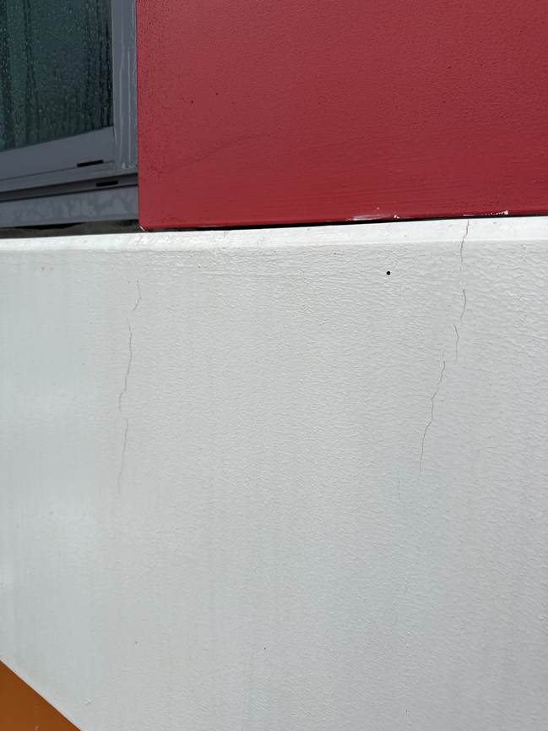 | E.9.1 - Concrete - Rust Spot  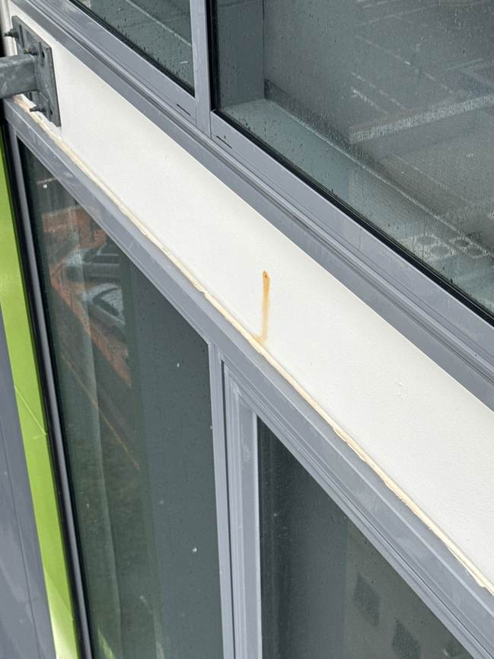
E.6.1 - Concrete - Cracking  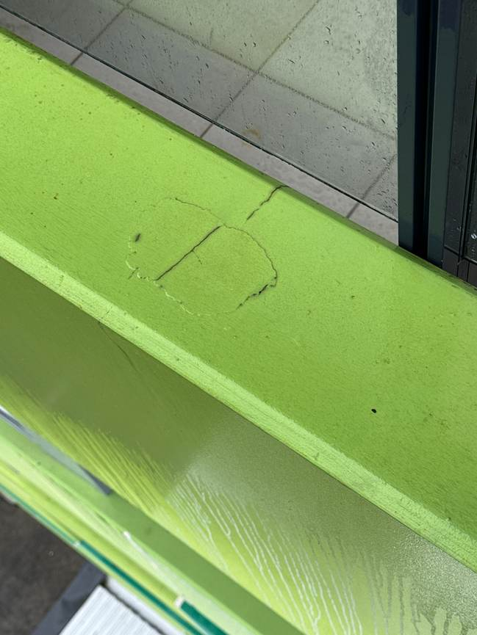 | E.5.1 - Coatings - Missing Paint  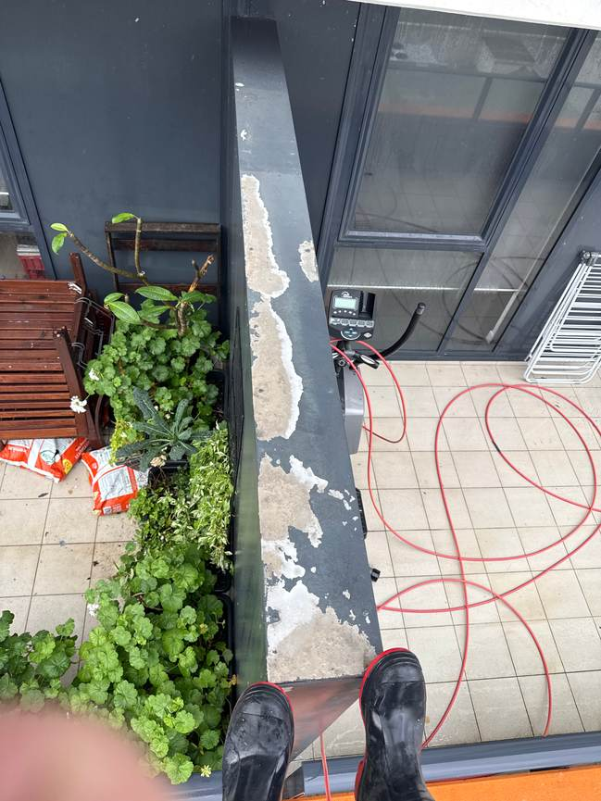

Drop F - Defect Schedule
Repair # | Level | Location | Defect Type | Length mm | Height mm | Depth mm | Qty | Round Up | Comments
F.6.1 | 6 | Slab Top | Concrete - Cracking | 800 |  |  |  | 1 LM | -
F.5.1 | 5 | Slab Top | Coatings - Paint Failure | 800 | 500 |  |  | 0.5 m2 | -
F.1.1 | 1 | Wall | Coatings - Paint mess |  |  |  |  | - | -
F.1.2 | 1 | Wall | Concrete - Cracking | 8000 |  |  |  | 8 LM | -

Drop F - Photo Schedule
F.6.1 - Concrete - Cracking  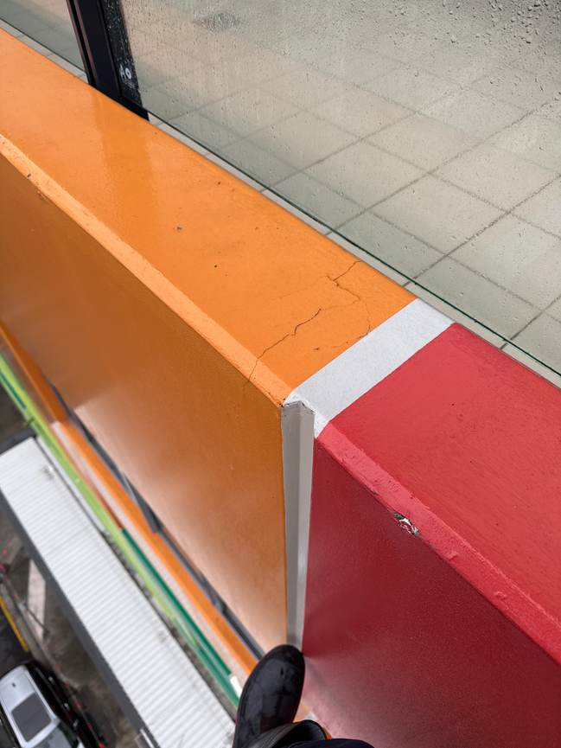 | F.5.1 - Coatings - Paint Failure  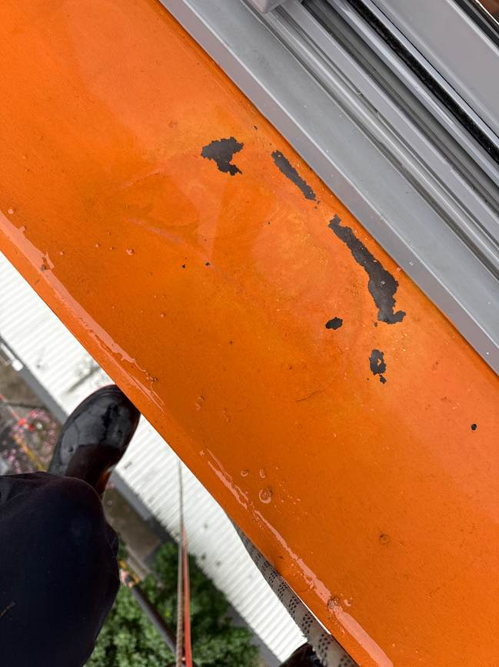 | F.1.1 - Coatings - Paint mess  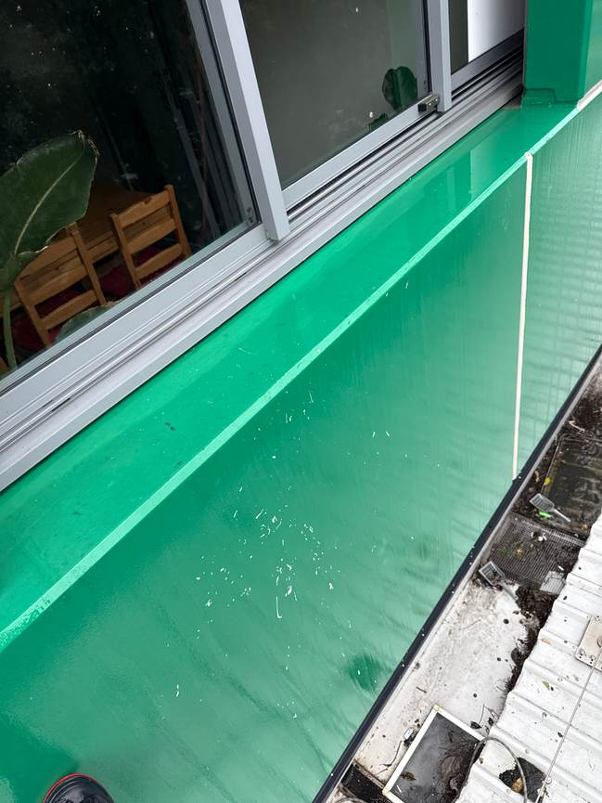
F.1.2 - Concrete - Cracking
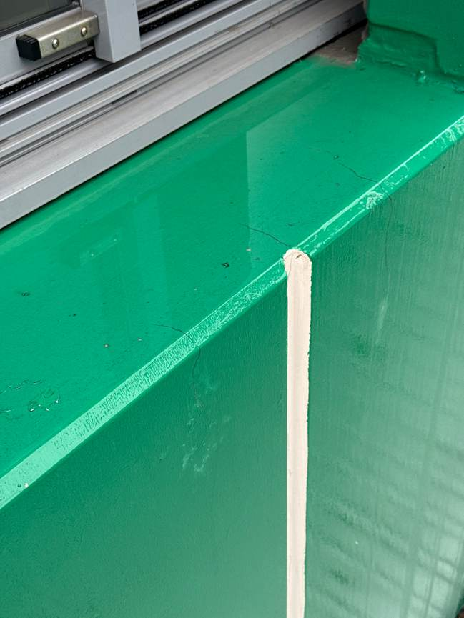
+1 additional photo available in Drive

Drop G - Defect Schedule
Repair # | Level | Location | Defect Type | Length mm | Height mm | Depth mm | Qty | Round Up | Comments
G.20.1 | 20 | Parapet Wall | Coatings - Missing Paint | 1 | 1 |  |  | 0.5 m2 | -
G.6.1 | 6 | Slab End | Concrete - Cracking | 60000 |  |  |  | 60 LM | -
G.5.1 | 5 | Column | Coatings - Missing Paint | 1444 | 3000 |  |  | 4.5 m2 | -
G.5.2 | 5 | Hob | Coatings - Efflorescence |  |  |  | 2 | 2 ea | -

Drop G - Photo Schedule
G.20.1 - Coatings - Missing Paint  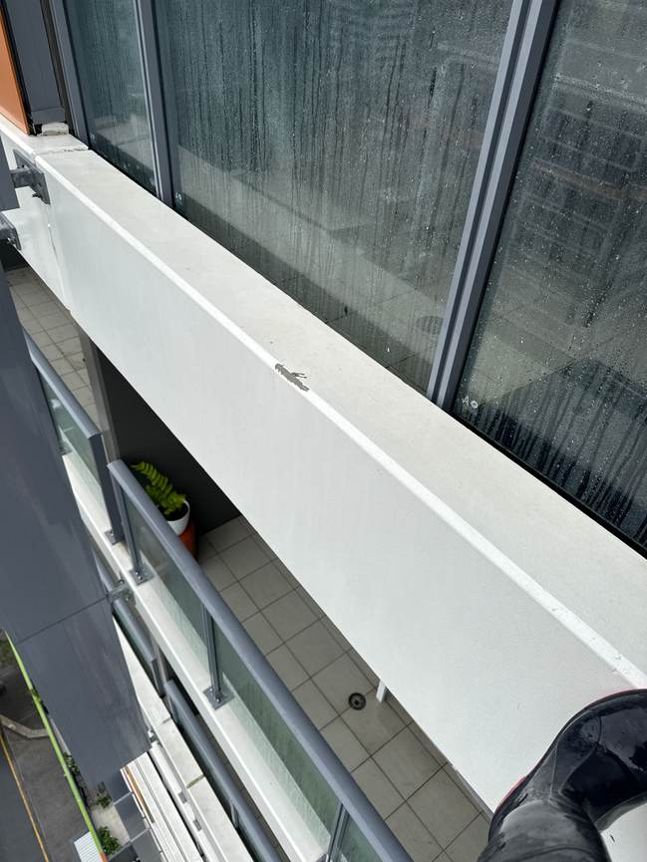 | G.6.1 - Concrete - Cracking  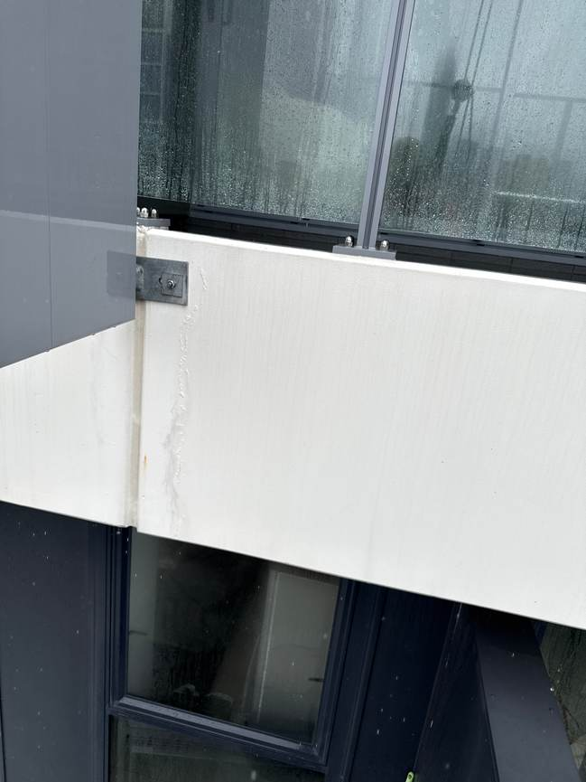 | G.5.1 - Coatings - Missing Paint  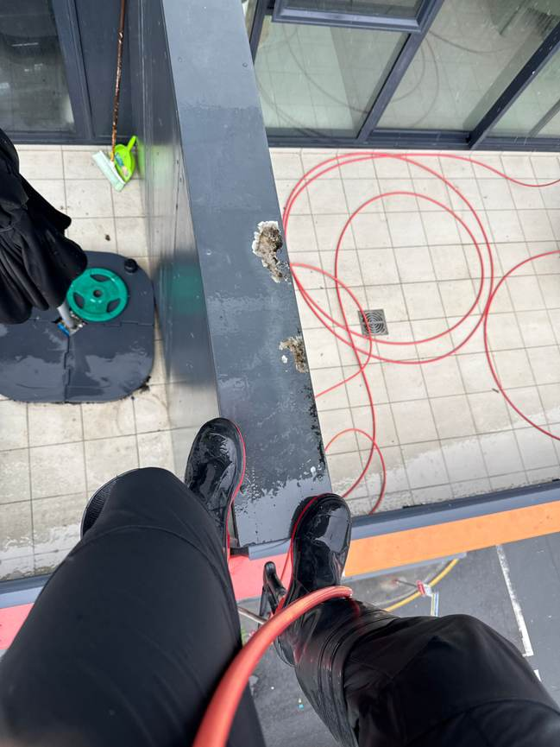
G.5.2 - Coatings - Efflorescence
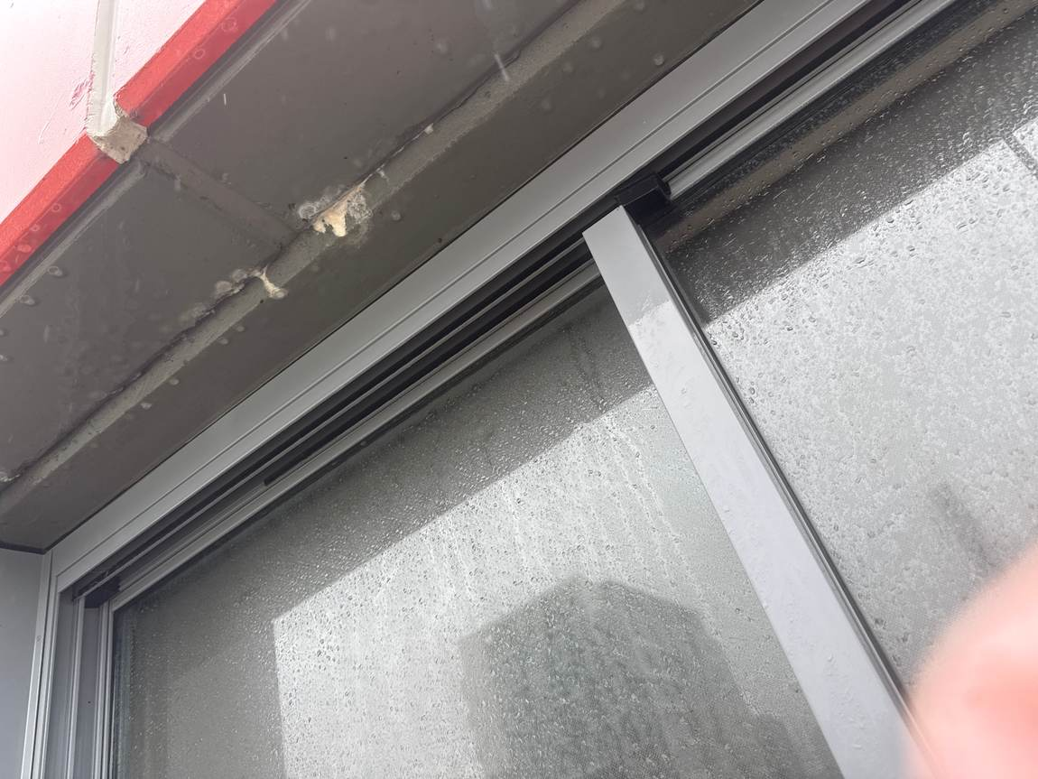
+1 additional photo available in Drive

Drop I - Defect Schedule
Repair # | Level | Location | Defect Type | Length mm | Height mm | Depth mm | Qty | Round Up | Comments
I.6.1 | 6 | Window | Caulking - Failing |  | 10 |  |  | 1 LM | -
I.2.1 | 2 | Wall | Coatings - Efflorescence |  |  |  | 3 | 3 ea | -
I.1.1 | 1 | Wall | Concrete - Cracking | 500 |  |  |  | 1 LM | -
I.1.2 | 1 | Wall | Concrete - Cracking | 50000 |  |  |  | 50 LM | -

Drop I - Photo Schedule
I.6.1 - Caulking - Failing  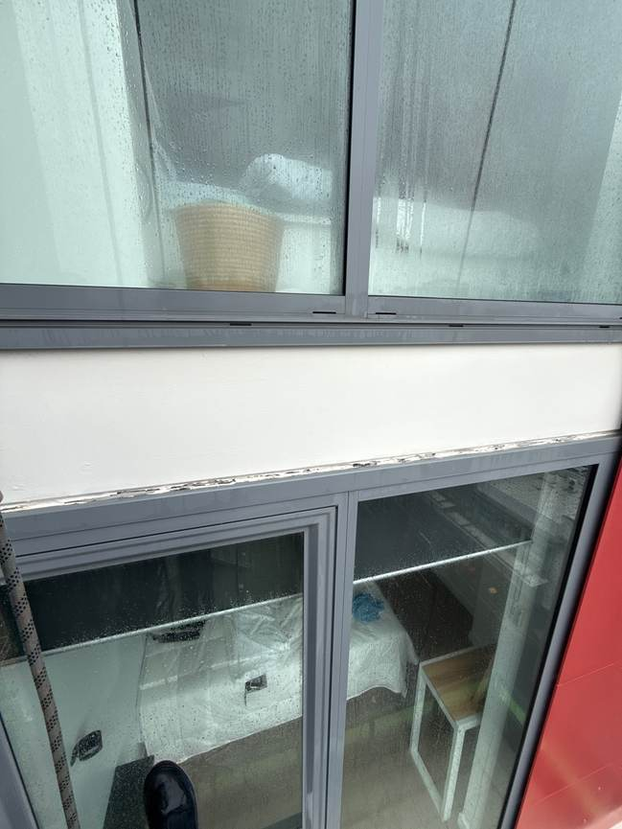 | I.2.1 - Coatings - Efflorescence  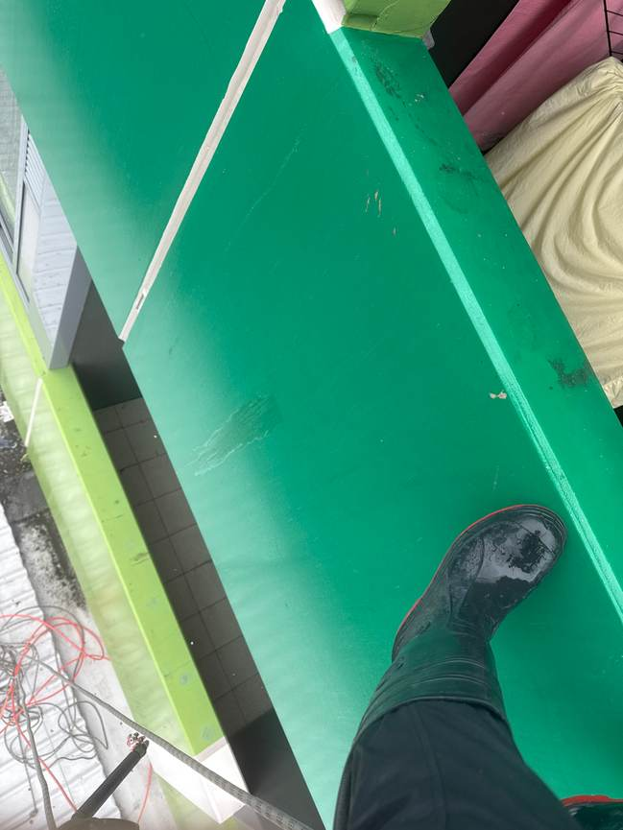 | I.1.1 - Concrete - Cracking  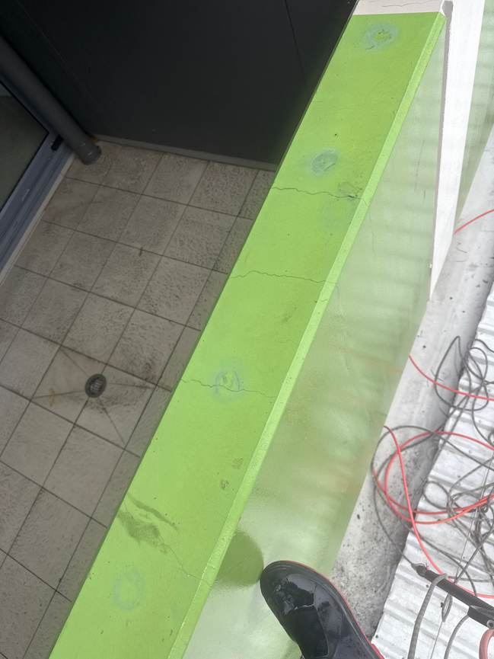
I.1.2 - Concrete - Cracking
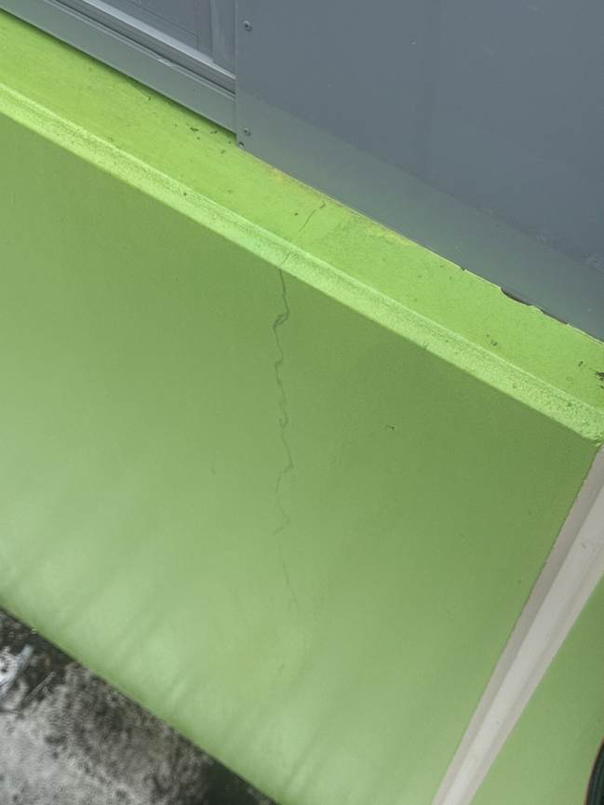

Drop J - Defect Schedule
Repair # | Level | Location | Defect Type | Length mm | Height mm | Depth mm | Qty | Round Up | Comments
J.20.1 | 20 | Wall | Coatings - Paint Failure | 1000000 | 1000000 |  |  | 1,000,000 m2 | -
J.19.1 | 19 | Wall | Brick Work - Cracking |  |  |  | 15000 | 15,000 ea | -
J.19.2 | 19 | Wall | Coatings - Missing Paint | 3000 | 3000 |  |  | 9 m2 | -
J.18.1 | 18 | Slab End | Windows & Doors - Frame Defect |  |  |  | 1 | 1 ea | -
J.11.1 | 11 | Slab End | Waterproofing - Pin Holing | 10000 | 100 |  |  | 1 m2 | -
J.9.1 | 9 | Wall | Caulking - Failing |  | 100 |  |  | 1 LM | -

Drop J - Photo Schedule
J.20.1 - Coatings - Paint Failure  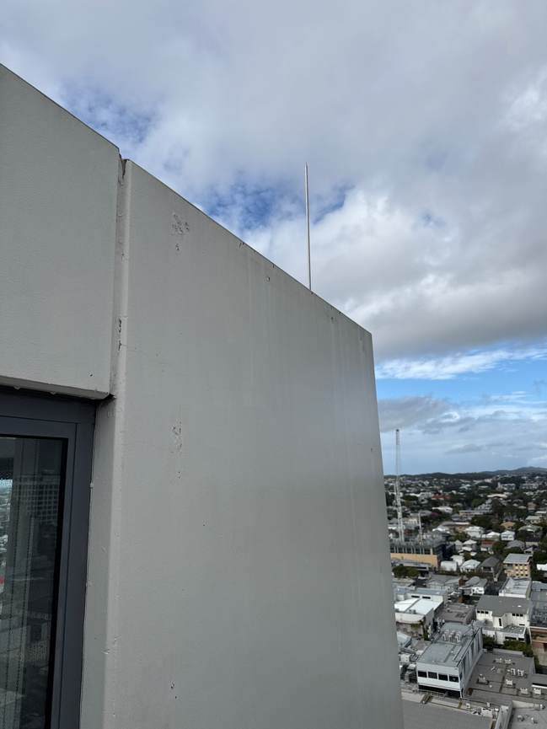 | J.19.1 - Brick Work - Cracking  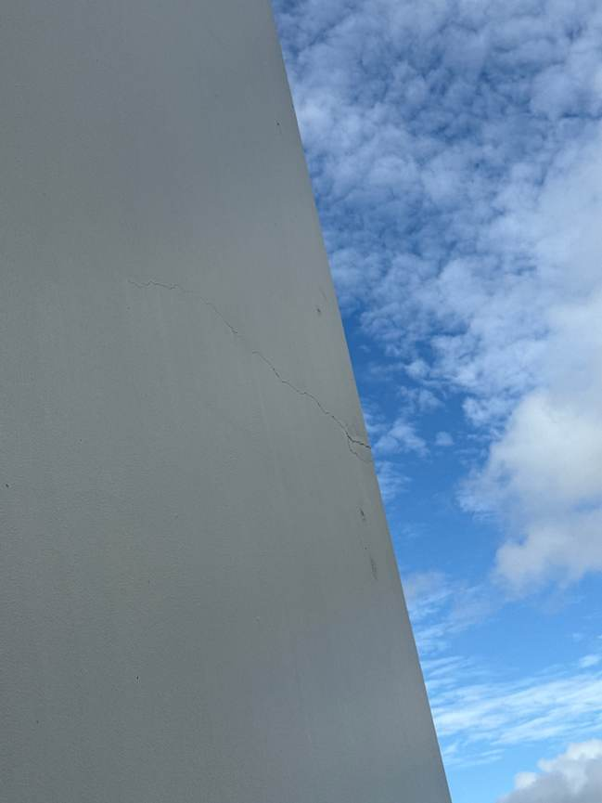 | J.19.2 - Coatings - Missing Paint  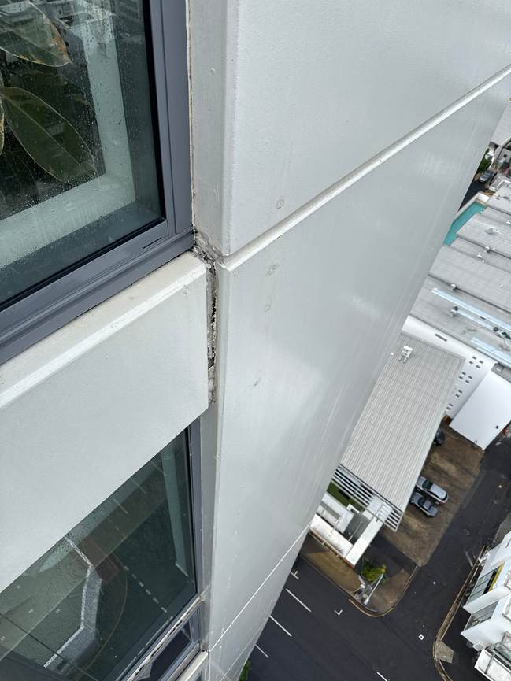
J.18.1 - Windows & Doors - Frame Defect  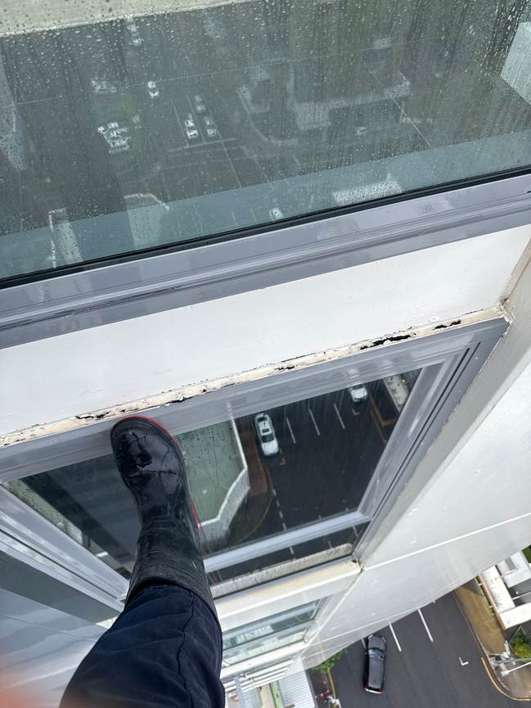 | J.11.1 - Waterproofing - Pin Holing  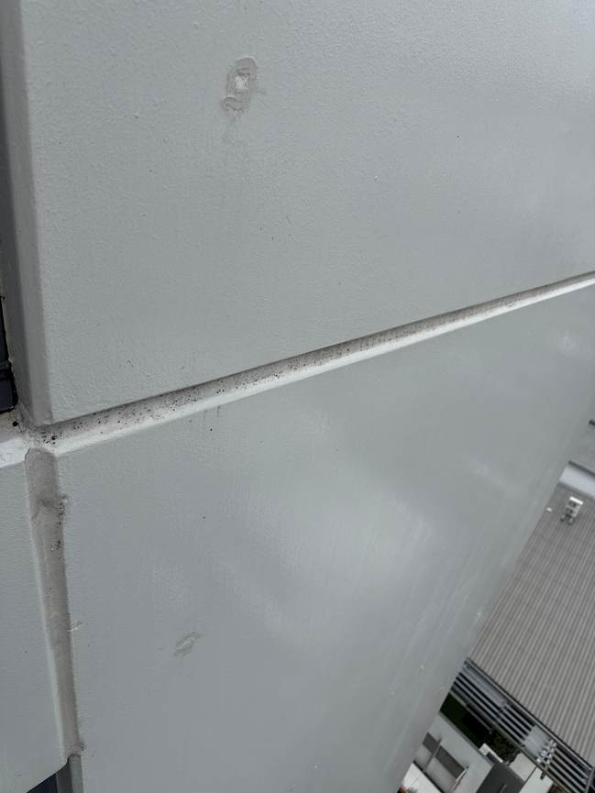 | J.9.1 - Caulking - Failing  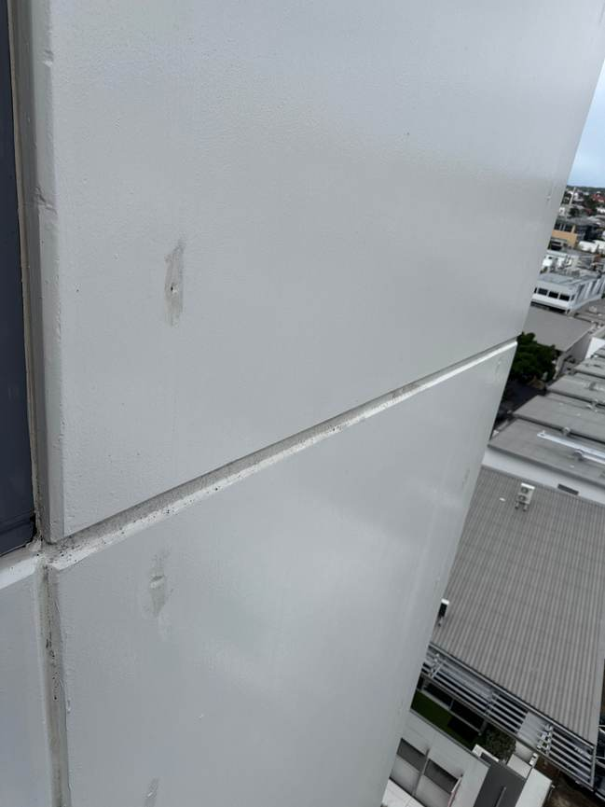

Drop K - Defect Schedule
Repair # | Level | Location | Defect Type | Length mm | Height mm | Depth mm | Qty | Round Up | Comments
K.20.1 | 20 | Slab Top | Concrete - Spalling | 600 | 60 | 30 |  | 5 L | -
K.10.1 | 10 | Wall | Concrete - Cracking | 500 |  |  |  | 1 LM | -
K.6.1 | 6 | Wall | Concrete - Cracking | 1500 | 1500 |  |  | 2 LM | -

Drop K - Photo Schedule
K.20.1 - Concrete - Spalling  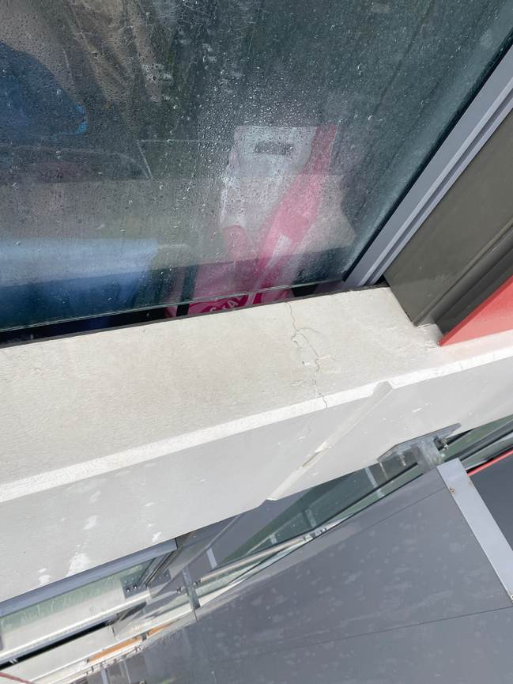 | K.10.1 - Concrete - Cracking  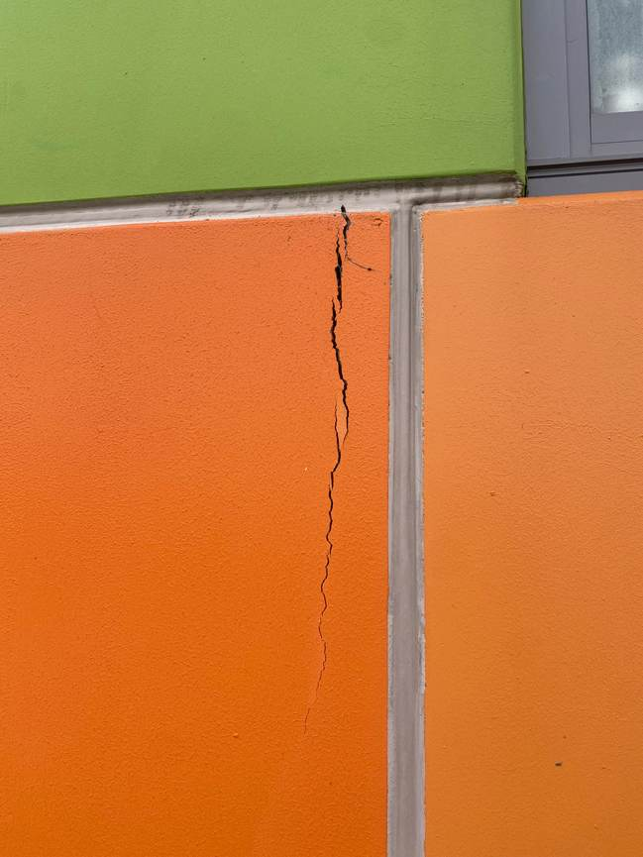 | K.6.1 - Concrete - Cracking  